**Project Report: FaultFindy - Predictive Maintenance for Manufacturing**

**1. Introduction:**

The objective of this project is to develop an intelligent system using deep learning to predict the faults in manufacturing processes. By analyzing various manufacturing parameters and process data, the system will predict the faulty tyre generated during production. This predictive capability will enable manufacturers to proactively optimize their processes, reduce waste, and improve overall production efficiency.

**2. Problem Statement:**

Manufacturing facilities face significant challenges in detecting faulty tires during production. Defective tires can lead to safety hazards, product recalls, and financial losses. FaultFindy addresses this issue by leveraging historical data and sensor inputs to predict faulty tires before they leave the production line.

As they impact the business in below manner :

* Good tires are critical for safe and efficient operation of vehicles. Here are some key reasons why having good tires is important:
* Safety: Tires are the only contact point between the vehicle and the road surface. Good tires provide optimal traction, which is essential for maintaining control of the vehicle, especially during braking, accelerating, and cornering. Tires with sufficient tread depth and proper inflation help prevent skidding, hydroplaning, and loss of control, reducing the risk of accidents.
* Handling and Stability: Quality tires contribute to better handling and stability of the vehicle. They provide responsive steering and improved cornering performance, allowing drivers to maneuver safely and confidently, especially in challenging road conditions such as wet or slippery surfaces.
* Braking Distance: Tires play a crucial role in braking performance. Good tires with adequate tread depth and optimal grip reduce the braking distance, enabling the vehicle to stop more quickly and effectively in emergency situations, thereby enhancing overall safety on the road.
* Fuel Efficiency: Properly maintained tires can improve fuel efficiency. Low rolling resistance tires reduce the energy required to propel the vehicle forward, resulting in lower fuel consumption and reduced carbon emissions. By ensuring tires are properly inflated and aligned, drivers can maximize fuel efficiency and save money on fuel costs.
* Comfort and Ride Quality: Quality tires contribute to a smoother and more comfortable ride. They help dampen road vibrations and reduce noise, providing a quieter and more pleasant driving experience for occupants. Additionally, tires with good shock absorption properties enhance ride quality by minimizing bumps and jolts on uneven road surfaces.
* Longevity and Durability: Investing in high-quality tires can result in longer tread life and extended tire longevity. Quality tires are designed to withstand wear and tear, punctures, and road hazards, resulting in fewer tire replacements and maintenance costs over time.
* All-Weather Performance: Good tires are designed to perform well in various weather conditions, including dry, wet, and snowy conditions. All-season or winter tires with specialized tread patterns and rubber compounds provide enhanced traction and grip, ensuring safe driving regardless of weather conditions.
* Vehicle Performance and Handling: Tires influence the overall performance and dynamics of the vehicle. They affect acceleration, braking, cornering, and stability, contributing to the overall driving experience. Choosing tires that match the vehicle's specifications and intended use (e.g., passenger car, SUV, truck, performance vehicle) ensures optimal performance and handling characteristics.

**3. Data Sources:**

* We have legitimated and authorized data source upgrade.
* The upgrade team provide us the data source.

**4. Exploratory Data analysis:**

* The Data was in the form of Zip file. with the help of zipfile library

Data extraction has been done.

* We found 1856 files belonging to 2 classes in directory “Digital images of defective and good condition tyres”
* We used tensorflow 🡪 keras🡪 utils🡪 image_dataset_from_directory module to load the dataset and create a dataset tensor object for further processing.
* Class names are = ['defective', 'good']
* Class Distribution is as below:
* defective: 1028 samples
* good: 828 samples
* The Visuals of Class distribution is:

The visuals are ploted with the help of matplotlib library (reference -\faultyFinding\visuals)

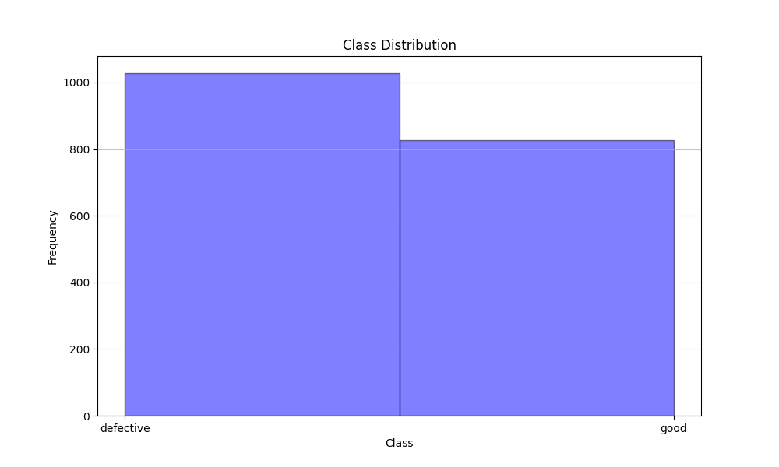

**5. Data Preprocessing:**

Since we tried multiple models of Deep learning and machine learning so based on model needs, we did the data preprocessing, the generalized steps is as below:

* Resizing: Images may come in various sizes, and resizing them to a uniform size is often necessary for model compatibility and efficiency.
* Normalization: Normalizing pixel values helps in improving model convergence and performance. Typically, this involves scaling pixel values to a range like [0, 1] or [-1, 1].
* Color Space Conversion: Converting images to different color spaces (e.g., RGB, grayscale, HSV) can sometimes improve model performance or reduce computational complexity.
* Handling Missing Data: Sometimes, images may have missing data or be corrupted. Dealing with such cases might involve image inpainting or removing the corrupted images from the dataset.

**These libraries are used to (cv2.resize, cv2.cvtColor, tf.keras.utils.image_dataset_from_directory)**

* Data Augmentation: This is helpful to give variety of angle to image data set so that the trained data set leveraging RandomFlip, RandomRotation, RandomZoom layers of keras.

**6. Feature Engineering:**

* This involves extracting relevant features from images that are informative for the given task. Features can include edges, textures, shapes, or more abstract representations learned through convolutional neural networks (CNNs).
* Dimensionality Reduction: High-dimensional image data can be computationally expensive and prone to overfitting. Techniques like Principal Component Analysis (PCA) or t-SNE can be applied to reduce the dimensionality of the feature space while preserving important information.
* Histogram of Oriented Gradients (HOG): HOG is a feature descriptor technique used for object detection. It calculates the distribution of intensity gradients in localized portions of an image.

**hog(image, orientations=9, pixels_per_cell=(8, 8),cells_per_block=(2, 2), visualize=False) / vgg16 preprocess input /resent50 preprocess imput/mobilenetv2 preprocess input are libraries used for feature extraction**

[Summary of Data Preprocessing and Feature Engineering]

As we got the best output with RESNET -XGB Model so the final model consist of the preprocessing of cv2 and HOG and Resnet preprocessed layer used for preprocessing.

**7. Model Selection:**

This problem statement is part of Supervised learning and need to be classified in good or defective (Binary classification).

Below are some model which are compatible with Classification problem:

* Random Forest: Effective for handling high-dimensional data and capturing complex relationships between features.
* Gradient Boosting Machines (GBM): Provides high predictive accuracy by combining weak learners sequentially.
* Convolutional Neural Networks (CNN): Suitable for processing sequential sensor data and detecting patterns in time series.
  + Pre-Trained Layers (VGG16)
  + Pre-Trained Layer (MobileNetV2)
  + Pre-Trained Layer (Resnet50)
  + Pre-trained layers like VGG16, MobileNet, and ResNet50 are pre-trained convolutional neural network architectures, each with specific design choices and trained on large-scale image datasets, enabling transfer learning for various computer vision tasks.
* K Nearest Neighbor (KNN): It operates on the principle of proximity, where a data point is classified or predicted based on the majority class or average value of its nearest neighbors in the feature space.
* Decision Tree: It works by recursively partitioning the feature space into subsets based on the values of input features, with the goal of maximizing the homogeneity (or purity) of the target variable within each subset.

**Hyperparameter Tuning:**

* RandomizedSearchCV is a hyperparameter optimization technique used in machine learning for efficiently tuning the hyperparameters of a model., RandomizedSearchCV samples a specified number of hyperparameter combinations from the specified parameter space. This random sampling approach can significantly reduce the computational cost while still providing good results. RandomizedSearchCV is particularly useful when the hyperparameter space is large or when computational resources are limited. It helps in finding the optimal set of hyperparameters that maximize the performance of the model on a validation set, thus improving its generalization ability.
* Fine Tuning : is a technique in machine learning used to further optimize pre-trained models for specific tasks or datasets. It involves taking a pre-trained model, typically trained on a large and general dataset, and adjusting its parameters to better fit a new dataset or task. Fine-tuning typically involves unfreezing some or all of the layers of the pre-trained model and training them on the new data using a smaller learning rate. This allows the model to adapt its learned features to the nuances of the new dataset, potentially improving its performance. Fine-tuning is commonly used in transfer learning scenarios, where the knowledge gained from training on one task or dataset is leveraged to improve performance on a related task or dataset.

**8. Model Evaluation:**

The performance of FaultFindy's predictive models is evaluated using metrics such as:

* Accuracy: The proportion of correctly classified instances out of the total instances.
* Precision: The proportion of true positive predictions among all positive predictions.
* Recall (Sensitivity): The proportion of true positive predictions among all actual positives.
* F1-score: The harmonic mean of precision and recall, which balances between precision and recall.
* Confusion Matrix: A matrix showing the counts of true positive, true negative, false positive, and false negative predictions.
* ROC Curve: Receiver Operating Characteristic curve showing the trade-off between true positive rate and false positive rate.
* AUC-ROC: Area Under the ROC Curve, which measures the model's ability to distinguish between classes.
* Precision-Recall Curve: A curve showing the trade-off between precision and recall at different classification thresholds.

Below is the accuracy matrix of all the model:

**RESNET Pretrained Model and XGB collaborative model:**

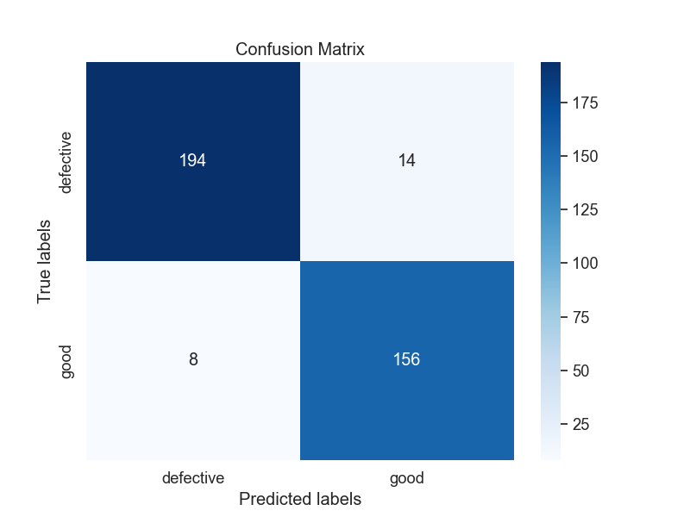

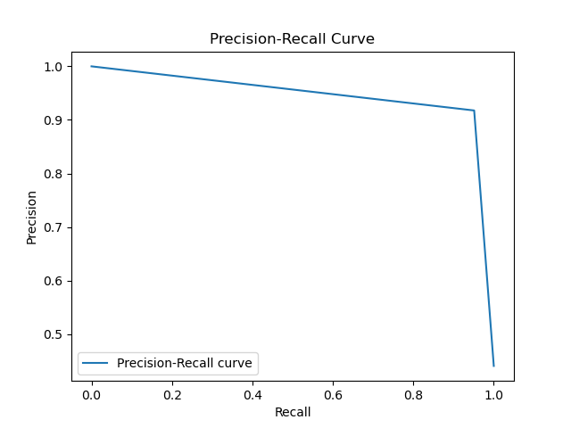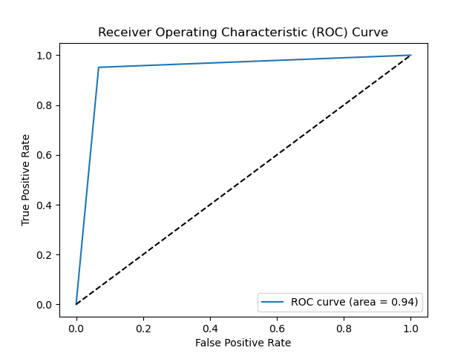

**9. Deployment:**

FaultFindy is deployed as a real-time monitoring system integrated into manufacturing equipment. It continuously analyzes sensor data streams and provides alerts or notifications when a faulty tire is detected. This enables proactive maintenance interventions to prevent defective products from reaching customers.

**10. Benefits:**

* Reduced Downtime: Early detection of faulty tires minimizes unplanned downtime and production disruptions.
* Cost Savings: Preventing defective products from reaching the market reduces costs associated with recalls and warranty claims.
* Improved Safety: Ensures the safety and reliability of manufactured tires, enhancing customer satisfaction and brand reputation.

**11. Future Enhancements:**

* Integration with IoT Platforms: Expand FaultFindy's capabilities by integrating with IoT platforms for seamless data collection and analysis from distributed sensor networks.
* Predictive Analytics: Develop advanced predictive analytics models to anticipate equipment failures and maintenance needs beyond tire defects.
* Continuous Learning: Implement feedback loops to incorporate new data and refine models over time, improving predictive accuracy and reliability.

**12. Conclusion:**

FaultFindy demonstrates the potential of machine learning and predictive maintenance techniques to address manufacturing challenges effectively. By harnessing the power of data and advanced analytics, FaultFindy empowers manufacturers to proactively identify and mitigate issues, ultimately driving operational excellence and customer satisfaction.

In summary, FaultFindy represents a transformative approach to predictive maintenance, paving the way for safer, more efficient manufacturing processes in the tire industry.